

Dr. Jacob, Davis inc.

2018-04-21

Dr. Davis

Unit 9546 Box 2569, DPO AA 45070

Phone: 4885176057

Fax: 704185518

**Re:** Sylvia, Evans

**PHN:** 5701004944

**Birthdate:** 22-Aug-1948

**Address:** 15537 Li Stream Suite 402, South Michael, SD 78955

**Patient number:** 6750463382

To Whom It May Concern:

This is a medical letter to state the above patient is pregnant with expected delivery date of 12-Aug-2025. Hoping this information is satisfactory for your requirements.

Thank you.

Sincerely,

Dr. Jacob, Davis

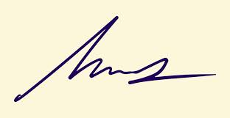

FRCS© NCMP

Clinical Assistant Professor, UBC

Department of Obstetrics and Gynecology SMH